Pygame street fight

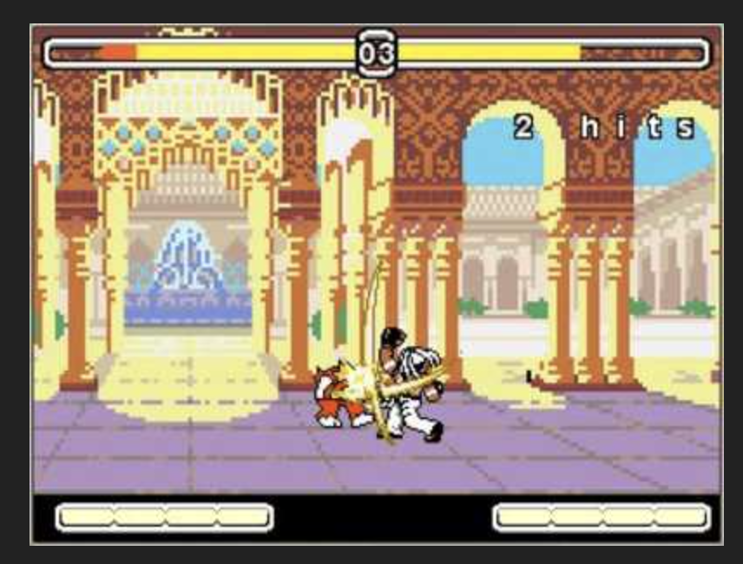

Add multiple abilities, chars, story lines

